**Flow:**

1. Numpy import convention
2. Why Numpy?
3. Initializing array
   1. .array()
   2. .arange()
   3. .linspace()
   4. .zeros() / .ones()
4. Properties of array
   1. .ndim
   2. .shape
   3. .dtype
5. Accessing Elements
   1. Indexing
   2. Slicing
   3. Masking/ Fancy indexing
6. Operations
   1. Arithmetic
   2. Comparison
   3. Matrix Multiplication
7. Axis (show it [diagrammatically](https://s3.amazonaws.com/assets.datacamp.com/blog_assets/Numpy_Python_Cheat_Sheet.pdf))
8. Universal Functions
   1. Aggregate
   2. Logical
9. Array Manipulation
   1. Reshaping
   2. Sorting
   3. Splitting
   4. Merging
10. Argument based function (topic name needs some work)
    1. Argwhere
    2. argmin/argmax
    3. argsort
11. Broadcasting
12. Copying Array
13. Misc

**Numpy**

**Import Convention**

Import numpy as np

**Why Numpy ?**

* Supports element wise operation + Vectorization
  + arr = np.array([1, 2, 3, 4])
    - Output: array([1, 2, 3, 4])
  + arr * 2
    - output: array([2, 4, 6, 8])
* Faster Execution speed
  + Python list (took **300 milli sec** for squaring elements)  
    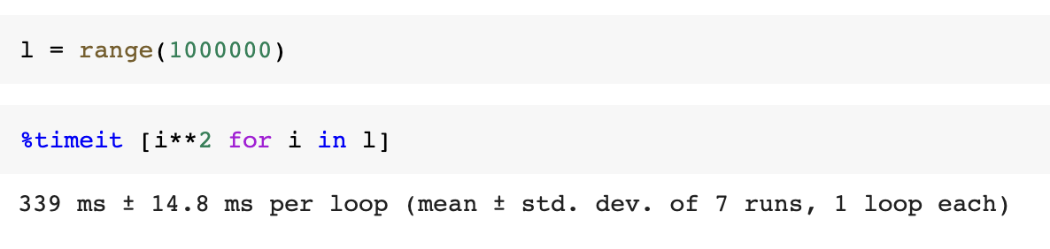
  + Numpy array (took **2 ms**)
    - Numpy internally uses C arrays.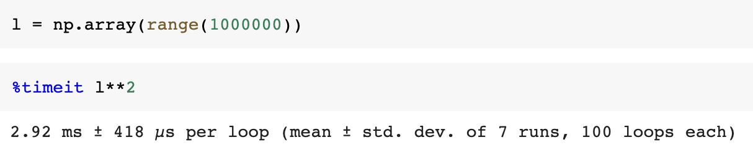

**Initializing Array**

| Initializing array using python list | arr1= np.array([4, 11, 53, 2, 9, ])  type(arr1)  > numpy.ndarray |
| --- | --- |
| Creates 2-D array of float data type  array([1., 2., 3.],  [4., 5., 6.]]) | arr2 = np.array([[2, 7 , 11], [4, 8 , 2]], dtype= float) |
| Initializing numpy array range. Similar to python range().  Step size can be float. | arr3 = np.arange(stop= 5)  # array([0, 1, 2, 3, 4])  arr4 = np.arange(start = 2, stop = 10,step = 1.5)  # array([2. , 3.5, 5. , 6.5, 8. , 9.5]) |
| Returns evenly spaced numbers over specified interval | np.linspace(start = 0, stop = 100,num =5)  # array([0, 25., 50. , 75., 100.])  np.linspace(0, 10, 5)  # array([ 0. , 2.5, 5. , 7.5, 10. ]) |
| Creates an array with all elements as 0  similar func: np.ones() | zero_arr = np.zeros(3)  # [0., 0., 0.]  zero_arr_2d= np.zeros((2,3))  # [[0., 0., 0.],  [0., 0., 0.]] |
| Generates array with elements belonging to continuous uniform distribution  Range: [0, 1) | np.random.rand(3, 2)  # array([[0.81595852, 0.59222987],  [0.30536743, 0.27175429],  [0.03835455, 0.27976716]]) |

**Properties of Array**

| number of dimensions of the array. | **arr.ndim**  arr1.ndim  # returns 1  arr2.ndim  # returns 2 |
| --- | --- |
| shape of array | **arr.shape**  arr1.shape  # returns (5, )  arr2.shape  # returns (2, 3) |
| datatype of array. | **arr.dtype**  arr1.dtype  # returns int64 |

**Accessing Elements**

**Accessing Single element (Indexing)**

| access element present at that index.  Index start from 0 | arr1[2]  # returns 53  arr2[1, 2]  # returns 6 |
| --- | --- |
| Negative index based indexing | arr1[-1]  # returns 6 |

**Accessing Sequence(Slicing)**

| Slice out and get part of the numpy array. Can use negative indexes for slicing as well.  Slicing returns View not copy. | arr1[3:] # returns [2, 9]  arr1[:4] # returns [4, 11, 53, 2]  arr[1: 4: 2]  #returns array([11, 2])  arr1[-4: -1] # returns [11, 53, 2] |
| --- | --- |
| arr2[:1, :]  # fetches first row  # [[2., 7. , 11.]]  arr2[:, 2:]  # fetches third column  # [[11.],  [2. ]] |

**Accessing based on condition (Masking)**

| Indexing based on condition.  Masking creates a copy of the array not a view. | arr1[arr1 > 8]  # returns [11, 53, 9]  arr1[(arr1 >5) & (arr1 <=11)]  # returns [11, 9] |
| --- | --- |
|

**Operations**

**Arithmetic**

a = np.array([1, 2, 3, 4])

b = np.array([1, 1, 2, 2])

| Element wise Addition | a + b [or np.add (a, b) ]  # [2, 3, 5, 6] |
| --- | --- |
| Element wise Subtraction | a - b [or np.subtract(a,b) ]  # [0, 1, 1, 2] |
| Element wise Multiplication | a * b [or np.multiply(a, b) ]  # [1, 2, 6, 8] |
| Element wise Division | a/b [pr np.divide(a, b)]  # [1., 2., 1.5., 2.] |

**Comparison**

| Element wise comparison  Returns bool array | a==b, a>=b, a<=b |
| --- | --- |
| Array wise equality  Returns True/False | np.array_equal(a, b) |

**Matrix Multiplication**

mat1 = np.array([[2], [1]])

mat2 = np.array([[2, 4]])

| Returns matrix mul. of arrays provided the condition for matrix multiplication is satisfied. | **np.matmul**(mat1, mat2)  # array([[4, 8],  [2, 4]]) |
| --- | --- |
| mat1 **@** mat2  # array([[4, 8],  [2, 4]]) |
| Performs matrix multiplication if both inputs are 2D.  Other cases for np.dot():  **Case1:** It performs dot product if both inputs are scalar  **Case2:** Perform simple multiplication if both inputs are scalars | **np.dot()**  np.dot(mat1, mat2)  # returns ([[4, 8],  [2, 4]]  np.dot(a, b)  # [2, 4, 6] =< 1*2 + 2*2 + 3*2  np.dot(2, 3)  # returns 6 |

**Axis**

Diagram ref: [Cheat sheet Numpy Python copy.indd](https://s3.amazonaws.com/assets.datacamp.com/blog_assets/Numpy_Python_Cheat_Sheet.pdf)

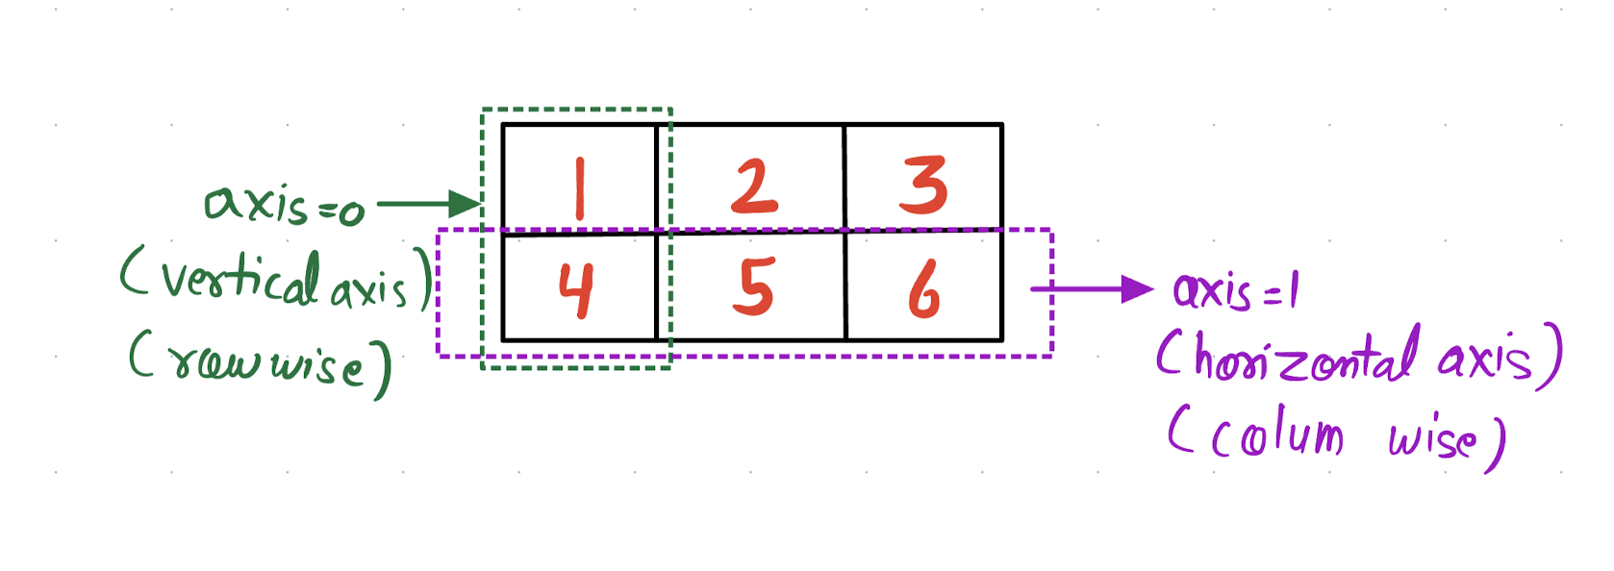

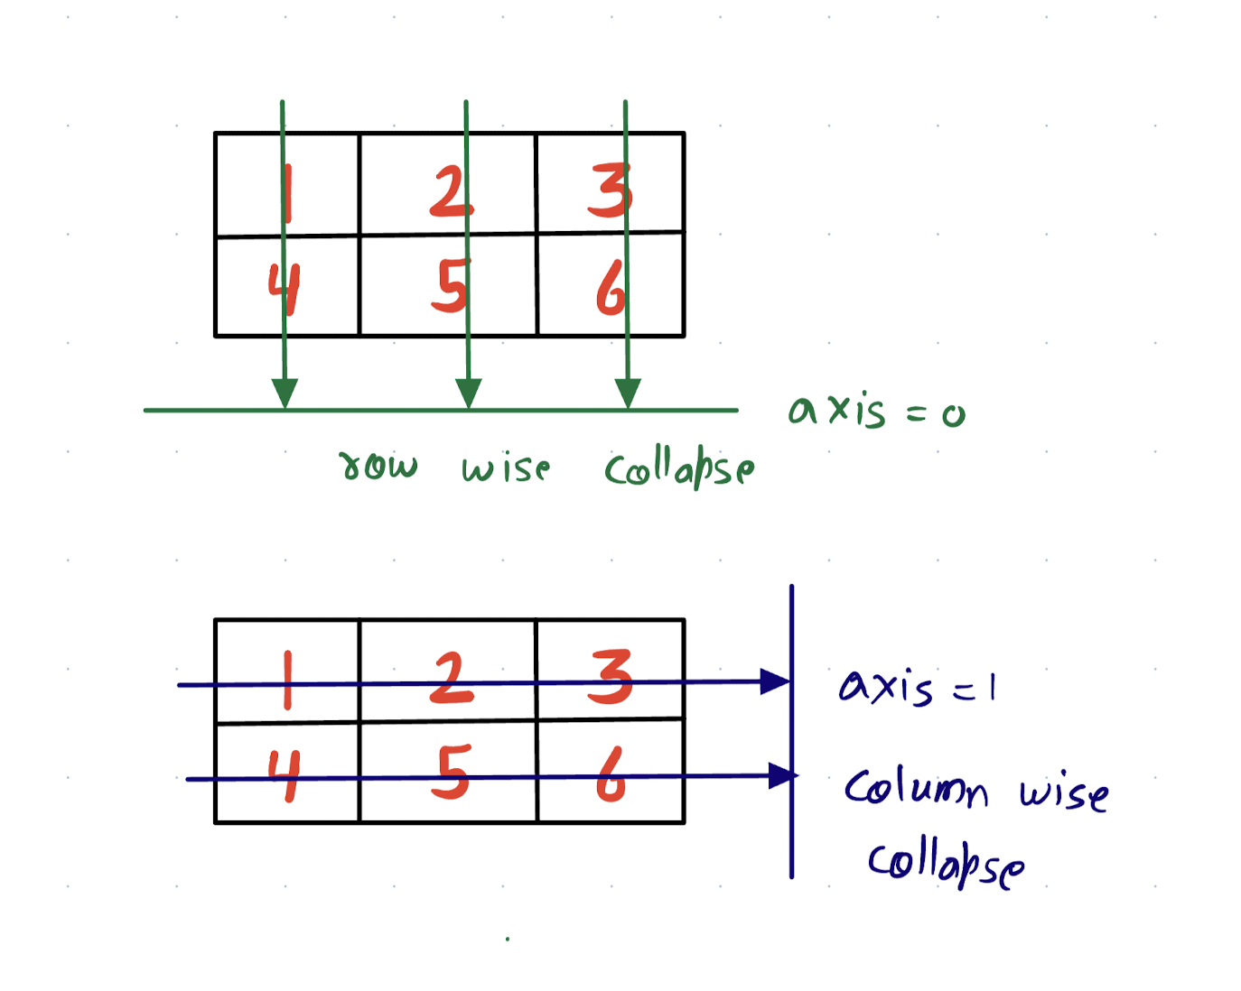

**Universal Functions**

**Aggregate**

| Sums all the elements of array  Sums the elements along the vertical axis(rowwise).  We can also take sum along horizontal axis (axis =1) | **np.sum()**  np.sum(arr2)  # retuns 34.0  np.sum(arr2, axis = 0)  # returns [6., 15., 3.] |
| --- | --- |
| Takes mean of all the elements of array  Takes mean along the horizontal axis (column wise) | np.mean(arr2)  # returns 5.666667  np.mean(arr2, axis = 1)  # [6.6667, 4.66667] |
| Returns element with minimum value. Can also find mean row wise/ column wise using axis 0/1  Other similar func: np.max() | np.min(arr2)  # returns 2.0 |

**Logical**

| Returns True if the any of the corresponding elements in the array follow provided condition | np.any(arr1 < arr3)  # returns True |
| --- | --- |
| Returns True only if the all of the corresponding elements in the array follow provided condition | np.all(arr1 < arr3)  # returns False |
| Function signature:  np.where(condition, [x, y])  Vectorized if else over an array.  Returns an array where value = x if the condition is True else y. | np.where(arr1 > 2, 1, 0)  # array([1, 1, 1, 0, 1]) |

**Array Manipulation**

**Reshaping**

array3d = np.array([[[1 , 2]],

[[5, 6]]])

| Reshapes the array  Can use -ve index in reshape | array3d.reshape(2, 2)  # returns [[1, 2],  [5, 6]]  arr5.reshape(2, -1)  # [[1, 2],  [5, 6]] |
| --- | --- |
| Returns a flattened array i.e. 1D array.  Returns copy of array | array3d.flatten()  # returns array([1, 2, 5, 6]) |
| Returns a flattened array.  Returns view of array | array3d.ravel() |
| Transposes the array | reshaped_arr.T  np.transpose(array3d, axis = [2, 1, 0])  # array([[[1, 5]],  [[2, 6]]]) |

**Sorting**

| Sorts original array. Doesn’t return anything | arr2.sort() |
| --- | --- |
| Returns sorted array. Doesn’t make changes to original array | np.sort(arr)  # array([[ 2., 7., 11.],  [ 2., 4., 8.]]) |
| Sorts array row wise i.e. along the vertical axis  Sorts array along the horizontal axis i.e. column wise | np.sort(arr, axis = 0)  # array([[ 2., 7., 2.],  [ 4., 8., 11.]])  np.sort(arr, axis = 1)  # array([[ 2., 7., 11.],  [ 2., 4., 8.]]) |
| Returns indices that would sort the array | np.argsort(arr)  # [4, 0, 3, 1, 2] |

**Splitting**

| Split array into multiple sub arrays | np.split(arr, indices_or_sections= 2)  # [array([1, 2]), array([3, 4])]  np.split(arr, indices_or_sections = [1, 3])  # [array([1]), array([2, 3]), array([4])] |
| --- | --- |
| Split along horizontal axis i.e. column wise | np.hsplit(arr2, [1, 2])  # [array([[2.], [4.]]), array([[7.], [8.]]), array([[11.], [ 2.]])] |
| Split along vertical axis i.e. row wise | np.vsplit(arr2, 2)  # [array([[ 2., 7., 11.]]), array([[4., 8., 2.]])] |

**Merging**

| Stacks array vertically ie. row wise append (axis = 0) | **np.vstack()**  np.vstack((arr, arr, arr))  # [[1, 2, 3, 4],  [1, 2, 3, 4],  [1, 2, 3, 4]] |
| --- | --- |
| Stacks array horizontally i.e. column wise append (axis = 1) | **np.hstack()**  arr = arr.reshape(4,1)  # [[0],  [1],  [2]]  np.hstack((arr, arr, arr))  # [[0, 0, 0],  [1, 1, 1],  [2, 2, 2],  [3, 3, 3]] |
| Concatenate two or more array along the given axis | np.concatenate([arr, arr])  # [1, 2, 3, 4, 1, 2, 3, 4]  arr_2d = arr.reshape(1,-1)  np.concatenate([arr, arr], axis = 0)  #[[1, 2, 3, 4],  [1, 2, 3, 4]]  np.concatenate([arr, arr], axis = 1)  array([[1, 2, 3, 4, 1, 2, 3, 4]]) |

**Argument based function**

| Get indices of non zero elements | np.argwhere(arr1)  # array([[0],  [1],  [2],  [3]  [4]]) |
| --- | --- |
| Get indices minimum value.  Other similar func: np.argmax() | np.argmin(arr1)  # returns 3  np.argmin(arr2)  # array([0, 0, 1]) |
| Returns indices that would sort the array | np.argsort(arr)  # array([3, 0, 4, 1, 2]) |

**Broadcasting**

| For each dimension ( going from right side)  1. The size of each dimension should be same OR  2. The size of one dimension should be 1  **Rule 1 :** If two arrays differ in the number of dimensions, the shape of one with fewer dimensions is padded with ones on its leading( Left Side).  **Rule 2 :** If the shape of two arrays does not match in any dimensions, the array with shape equal to 1 is stretched to match the other shape i.e. broadcasted.  **Rule 3 :** If in any dimension the sizes disagree and neither equal to 1 , then Error is raised. | Shape of arr1= (1, 2)  Shape of arr2 = (2, 2)  Shape of [arr1 + arr2] = (2, 2) **# Rule 2**  arr1 shape = (2, 1)  arr2 shape = (2, 2)  arr1 + arr2 shape = (2,2) **# Rule 2**  arr1 shape = (2, 4)  arr2 shape = (4, 4)  arr1 - arr2 shape = Error **# Rule 3**  arr1 shape = (15, 3, 5)  arr2 shape = (3, 1)  arr1 + arr2 shape = (15, 3, 5) **# Rule1 + Rule2** |
| --- | --- |

**Copying Array**

| Creates a copy of an array.  Masking and array op creates copy. | copy = arr1.copy() |
| --- | --- |
| Creates View of an array.  Slicing creates view | view = arr1.view() |

**Misc**

| Change the datatype of an array | arr.astype(int) |
| --- | --- |